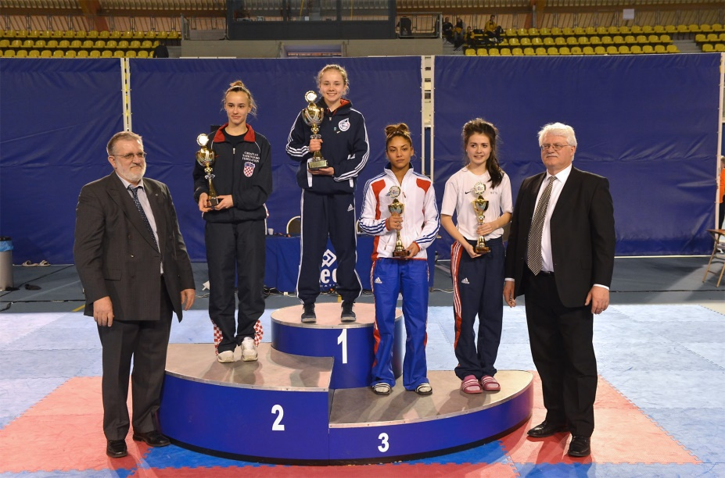
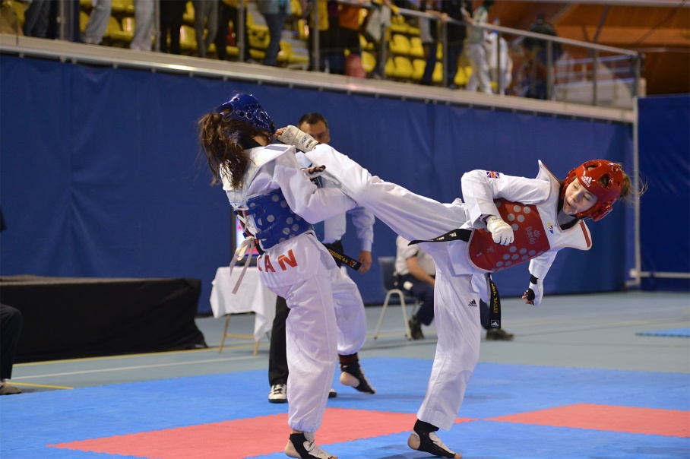
Asia Bailey

Grand Master Bailey’s Daughter
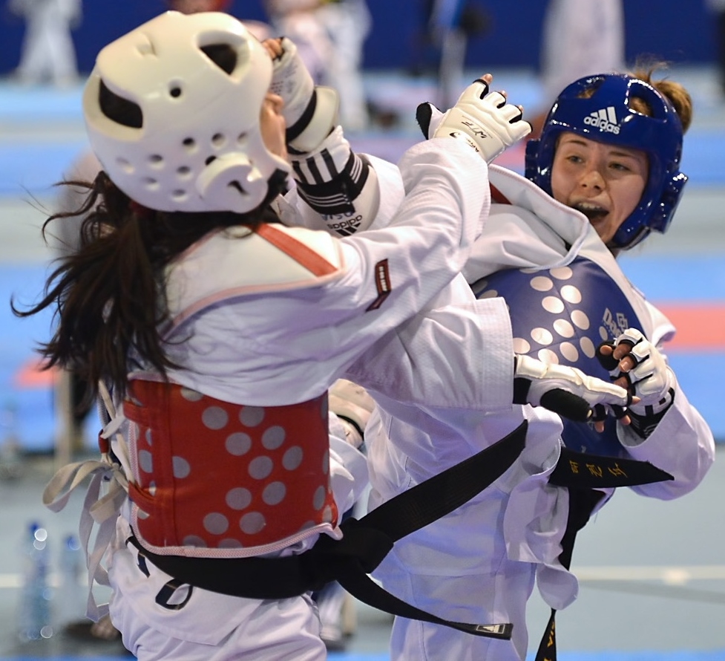
Asia has competed in European’s and World’s representing GB Taekwondo
Junior World’s Bronze Medallist 2012
Senior European Bronze Medallist 2014
Manchester Grand Prix Quarter Finalist 2015
And Commonwealth Silver Medallist representing Scotland
Trained with Jade Jones, Sarah Stevenson &all GB players down inManchester
Asia will be coming to Aberdeen to facilitate a sparring training session
Venue: Danestone Community Centre Time: 2pm-5pm
Bridge of Don
Aberdeen
AB22 8ZP
Open to any age and any grade. Licence must be presented at registration.
Please take your own protective gear if you have, our club has stock to borrow.
Fantastic opportunity to get some extra sparring training before the upcoming
Scottish Championships. £10 per person Spectators FREE
Coffee & tea available to purchase at the venue
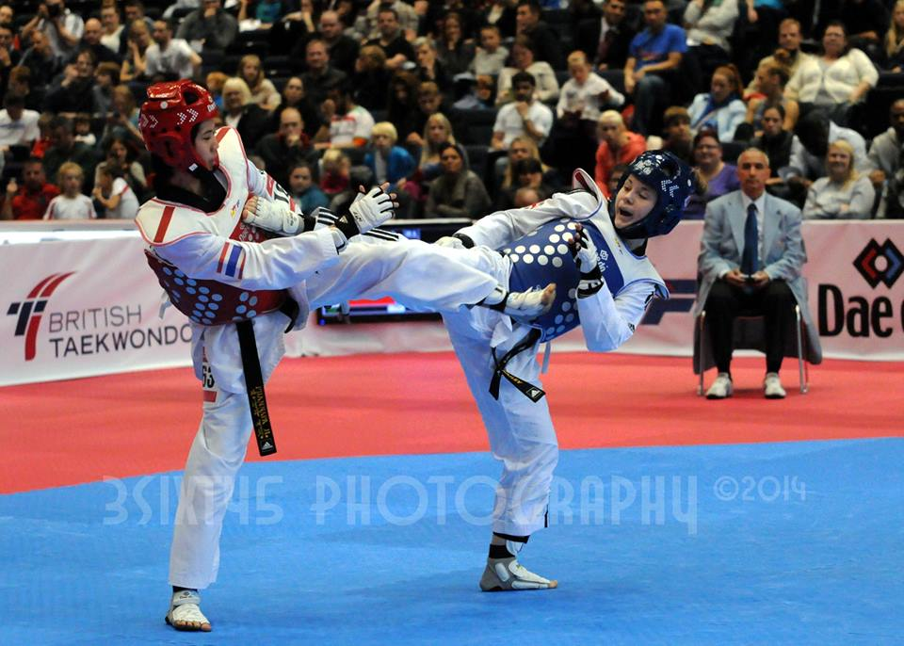
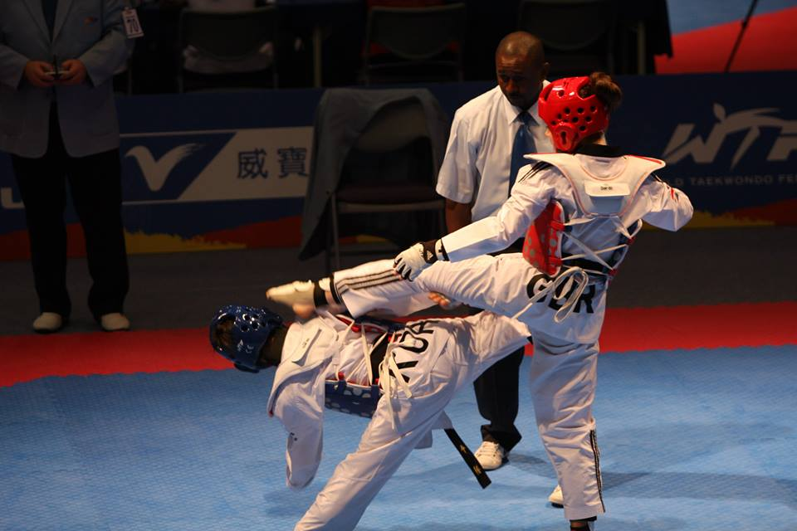
For further information please contact Master Lyndzie 07746 595935

